Development Documentation

DPP Test Instruction

Overview
This document describes the DPP test steps and instructions with wpa_supplicant. And list the wpa_supplicant commands used in test for each device role when dpp auth, dpp configure and associate.

References

Abbreviations and Acronyms
DPP | Device Provision Protocol
DUT | Device Under Test
CTT | Compliance Test Tool

Design Notes

Note : openssl should be updated to 1.02l in all devices running DPP (procedure mentioned in Appendix) and host_mlme=1 should be set during load

DUT as Enrollee, Initiator(Authentication), enrolled as STA
The command flow is as following. DUT act as initiator and enrollee, configured as STA. CTT1 act as configurator. CTT2 act as enrollee, configured as AP.
Refer to “5.1.1 STAUT configured in Enrollee STA role and acts as an authentication Initiator test” in Wi-Fi_CERTIFIED_Easy_Connect_Test_Plan_v3.0.pdf
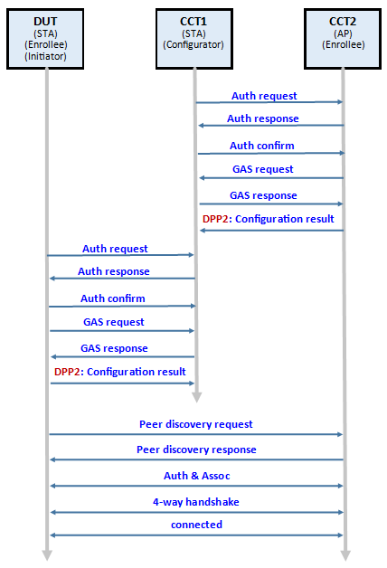
Figure 1. Frame Exchange Flow(QR)
In test, STA uses wpa_supplicant and AP uses hostapd. QR code test steps(values in () represent command returned value. Command in <> represent optional value):
- CTT2: wlan-set-mac 00:50:43:02:11:01
- CTT2: wlan-add testAP ssid DPPNET01 ip:192.168.10.1,192.168.10.1,255.255.255.0 role uap channel 11 wpa2 ThisIsDppPassphrase
3. CTT2: wlan-start-network testAP
4. CTT2: wlan-dpp-bootstrap-gen "type=qrcode chan=81/11 mac=00:50:43:02:12:01"
bootstrap generate id = 1
5. CTT2: wlan-dpp-bootstrap-get-uri <bootstrap_id>
Bootstrapping QR Code URI:
DPP:C:81/11;M:005043021201;V:3;K:……
6. CTT1: wlan-set-mac 00:50:43:02:11:03
7. CTT1: wlan-dpp-configurator-add
conf_id = 1
8. CTT1: wlan-dpp-qr-code DPP:C:81/11;M:005043021201;V:3;K:……
DPP qr code id = 1
9. CTT1: wlan-dpp-auth-init " peer=<qrcode_id> conf=ap-dpp ssid=4450504e45543031 configurator=< conf_id>"
# ssid=DPPNET01 for example: ssid=4450504e45543031
Results:
CTT2: DPP-AUTH-SUCCESS, DPP-CONF-RECEIVED, DPP-CONFOBJ-AKM, DPP-CONFOBJ-SSID, DPP-CONNECTOR, DPP-C-SIGN-KEY, DPP-NET-ACCESS-KEY
CTT1: DPP-AUTH-SUCCESS, DPP-CONF-SENT

10. CTT1: wlan-dpp-configurator-params " conf=sta-dpp ssid=<hex_ascii> configurator=< conf_id>"
# space character exists between “ & conf word.
11. CTT1: wlan-dpp-bootstrap-gen "type=qrcode chan=81/11 mac=00:50:43:02:11:03"
bootstrap generate id = 1
12. CTT1: wlan-dpp-bootstrap-get-uri <bootstrap_id>
Bootstrapping QR Code URI:
DPP:C:81/11;M:005043021103;V:3;K:…….
13. CTT1: wlan-dpp-listen "2462 role=configurator"
14. DUT: wlan-set-mac 00:50:43:02:11:02
15. DUT: wlan-dpp-qr-code DPP:C:81/11;M:005043021103;V:3;K:……….
DPP qr code id = 1
16. DUT: wlan-dpp-auth-init " peer=1 role=enrollee"
Results:
DUT: DPP-AUTH-SUCCESS, DPP-CONF-RECEIVED, DPP-CONFOBJ-SSID, DPP-CONNECTOR, DPP-C-SIGN-KEY, DPP-NET-ACCESS-KEY
CTT1: DPP-AUTH-SUCCESS, DPP-CONF-SENT

Connection between DUT and CTT2 success and ping can work for more than 30 seconds.

PKEX Test Steps:
- CTT2: wlan-set-mac 00:50:43:02:11:01
- CTT2: wlan-add testAP ssid DPPNET01 ip:192.168.10.1,192.168.10.1,255.255.255.0 role uap channel 6 wpa2 ThisIsDppPassphrase
3. CTT2: wlan-start-network testAP
4. CTT2: wlan-dpp-bootstrap-gen "type=pkex"
bootstrap generate id = 1
5. CTT2: wlan-dpp-pkex-add " own=<bootstrap_id> identifier=DPP_Device_PKEX code=secret"
6. CTT1: wlan-set-mac 00:50:43:02:11:03
7. CTT1: wlan-dpp-configurator-add
conf_id = 1
8. CTT1: wlan-dpp-bootstrap-gen "type=pkex"
bootstrap generate id = 1
9. CTT1: wlan-dpp-pkex-add " own=1 identifier=DPP_Device_PKEX init=1 conf=ap-dpp ssid=4450504e45543031 configurator=1 code=secret"
Results:
CTT2: DPP-AUTH-SUCCESS, DPP-CONF-RECEIVED, DPP-CONFOBJ-AKM, DPP-CONFOBJ-SSID, DPP-CONNECTOR, DPP-C-SIGN-KEY, DPP-NET-ACCESS-KEY
CTT1: DPP-AUTH-SUCCESS, DPP-CONF-SENT

10. CTT1: wlan-dpp-configurator-params " conf=sta-dpp ssid=<hex_ascii> configurator=< conf_id>"
# space character exists between “ & conf word.
11. CTT1: wlan-dpp-bootstrap-gen "type=pkex curve=P-256"
bootstrap generate id = 3
12. CTT1: wlan-dpp-pkex-add " own=3 identifier=DPP_Device_PKEX code=secret"
13. CTT1: wlan-dpp-listen "2437 role=configurator"
14. DUT: wlan-set-mac 00:50:43:02:11:02
15. DUT: wlan-dpp-bootstrap-gen "type=pkex curve=P-256"
bootstrap generate id = 1
16. DUT: wlan-dpp-pkex-add " own=1 identifier=DPP_Device_PKEX init=1 role=enrollee ssid=4450504e45543031 code=secret"
Results:
DUT: DPP-AUTH-SUCCESS, DPP-CONF-RECEIVED, DPP-CONFOBJ-SSID, DPP-CONNECTOR, DPP-C-SIGN-KEY, DPP-NET-ACCESS-KEY
CTT1: DPP-AUTH-SUCCESS, DPP-CONF-SENT

Connection between DUT and CTT2 success and ping can work for more than 30 seconds.

DUT as Enrollee, Responder(Authentication), enrolled as STA
The command flow as following. DUT act as responder and enrollee, configured as STA. CTT1 act as configurator. CTT2 act as enrollee, configured as AP.
Refer to “5.1.2 STAUT configured in Enrollee STA role and acts as an authentication Responder test” in Wi-Fi_CERTIFIED_Easy_Connect_Test_Plan_v3.0.pdf
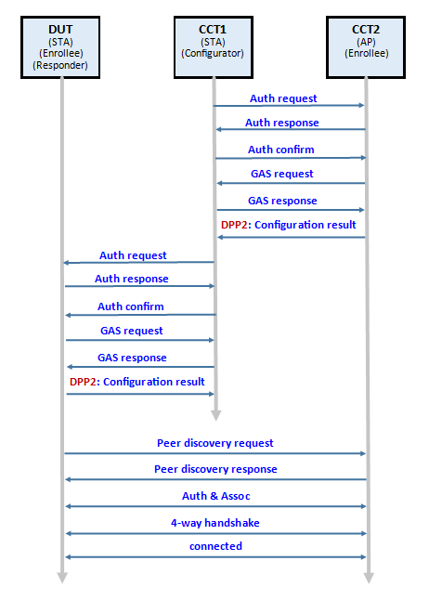
Figure 2. Frame Exchange Flow(QR)

In test, STA uses wpa_supplicant and AP uses hostapd. QR code test steps(values in () represent command returned value. Command in <> represent optional value):
1. Please configure CCT1 & CCT2 refer from step 1~9 of refer “4.1 DUT as Enrollee, Initiator(Authentication), enrolled as STA”.
2. DUT: wlan-set-mac 00:50:43:02:11:02
3. DUT: wlan-dpp-bootstrap-gen "type=qrcode chan=81/11 mac=00:50:43:02:11:02"
bootstrap generate id = 1
4. DUT: wlan-dpp-bootstrap-get-uri <bootstrap_id>
Bootstrapping QR Code URI:
DPP:C:81/11;M:005043021102;V:3;K:……
5. DUT: wlan-dpp-listen "2462 role=enrollee"
6. CTT1: wlan-dpp-qr-code DPP:C:81/11;M:005043021102;V:3;K:……
7. CTT1: wlan-dpp-auth-init " peer=1 conf=ap-dpp ssid=4450504e45543031 configurator=< conf_id>"
# ssid=DPP_TEST for example: ssid=4450504e45543031
Results:
DUT: DPP-CONF-RECEIVED, DPP-CONFOBJ-AKM, DPP-CONFOBJ-SSID, DPP-CONNECTOR, DPP-C-SIGN-KEY, DPP-PP-KEY, DPP-NET-ACCESS-KEY
CTT1: DPP-AUTH-SUCCESS, DPP-CONF-SENT
Connection between DUT and CTT2 success and ping can work for more than 30 seconds.

DUT as Enrollee STA, using different bootstrapping key and signing key elliptical curve test
The command flow as following. DUT act as initiator/responder and enrollee, configured as STA. CTT1 act as configurator. CTT2 act as enrollee, configured as AP.
Refer to “5.1.3 STAUT configured in Enrollee STA using different bootstrapping key and signing key elliptical curve test” in Wi-Fi_CERTIFIED_Easy_Connect_Test_Plan_v3.0.pdf
In test, STA uses wpa_supplicant and AP uses hostapd. QR code test steps(values in () represent command returned value. Command in <> represent optional value):
Determine the complexity of the elliptical curve according to the capability of the HW accelerator, he length of the elliptical curve will affect the operation time, resulting in DPP protocol timeout and failed.
DUT Authentication Role is initiator(5.1.3_I_P256_P384):
Please refer the test procedure of “4.1 DUT as Enrollee, Initiator(Authentication), enrolled as STA”, and change some steps:
Change step 4.1.7. CTT1: wlan-dpp-configurator-add
To 7. CTT1: wlan-dpp-configurator-add " curve=P-384"
# space character exists between “ & curve= word.
Change step 4.1.11. CTT1: wlan-dpp-bootstrap-gen "type=qrcode chan=81/11 mac=00:50:43:02:11:03"
To 11. CTT1: wlan-dpp-bootstrap-gen "type=qrcode chan=81/11 mac=00:50:43:02:11:03 curve=P-256"

DUT Authentication Role is responder(5.1.3_R_P256_P384):
Please refer the test procedure of “4.2 DUT as Enrollee, Responder(Authentication), enrolled as STA”, and change some steps:
Change step 4.1.7. CTT1: wlan-dpp-configurator-add
To 7. CTT1: wlan-dpp-configurator-add " curve=P-384"
# space character exists between “ & curve= word.
Change step 4.2.3. DUT: wlan-dpp-bootstrap-gen "type=qrcode chan=81/11 mac=00:50:43:02:11:02"
To 3. DUT: wlan-dpp-bootstrap-gen "type=qrcode chan=81/11 mac=00:50:43:02:11:02 curve=P-256"

DUT as Enrollee STA, Initiator(Authentication), handles STATUS_RESPONSE_PENDING during authentication test
The command flow as following. DUT act as initiator and enrollee, configured as STA. CTT1 act as configurator. CTT2 act as enrollee, configured as AP.
Refer to “5.1.4 STAUT configured in Enrollee STA role acting as an authentication Initiator handles STATUS_RESPONSE_PENDING during authentication test” in Wi-Fi_CERTIFIED_Easy_Connect_Test_Plan_v3.0.pdf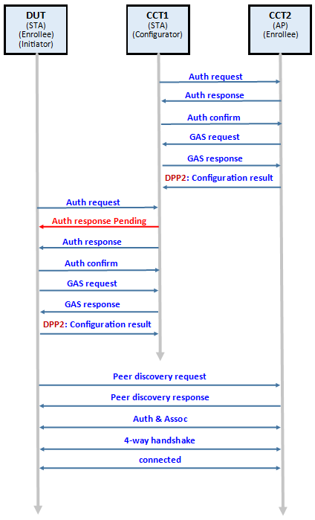 Figure 3. Frame Exchange Flow(QR)
In test, STA uses wpa_supplicant and AP uses hostapd. QR code test steps(values in () represent command returned value. Command in <> represent optional value):
Please refer the test procedure of “4.1 DUT as Enrollee, Initiator(Authentication), enrolled as STA”, and change some steps after 4.1.13:
13. CTT1: wlan-dpp-listen "2462 role=configurator qr=mutual"
14. DUT: wlan-set-mac 00:50:43:02:11:02
15. DUT: wlan-dpp-qr-code DPP:C:81/11;M:005043021103;V:3;K:……….
DPP qr code id = 1
16. DUT: wlan-dpp-auth-init " peer=1 role=enrollee"
Wait to see the string in console “DPP-RESPONSE-PENDING DPP:V:3;K:……;;”
17. CCT1: wlan-dpp-qr-code DPP:V:3;K:……;;
Enter the URI from “DPP-RESPONSE-PENDING”
Results:
DUT: DPP-AUTH-SUCCESS, DPP-CONF-RECEIVED, DPP-CONFOBJ-SSID, DPP-CONNECTOR, DPP-C-SIGN-KEY, DPP-NET-ACCESS-KEY
CTT1: DPP-AUTH-SUCCESS, DPP-CONF-SENT

Connection between DUT and CTT2 success and ping can work for more than 30 seconds.

DUT as Enrollee STA, Responder(Authentication), handles STATUS_RESPONSE_PENDING during authentication test
The command flow as following. DUT act as responder and enrollee, configured as STA. CTT1 act as configurator. CTT2 act as enrollee, configured as AP.
Refer to “5.1.5 STAUT configured in Enrollee STA role acting as an authentication Responder sends STATUS_RESPONSE_PENDING during authentication test” in Wi-Fi_CERTIFIED_Easy_Connect_Test_Plan_v3.0.pdf
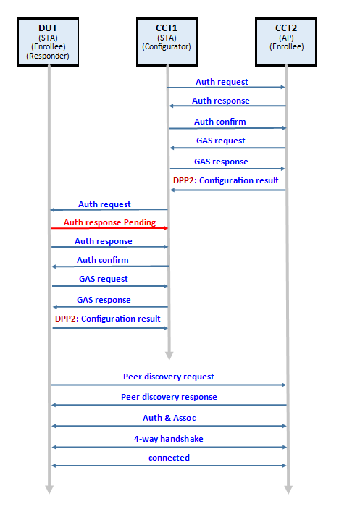 Figure 4. Frame Exchange Flow(QR)
In test, STA uses wpa_supplicant and AP uses hostapd. QR code test steps(values in () represent command returned value. Command in <> represent optional value):
Please refer the test procedure of “4.2 DUT as Enrollee, Responder(Authentication), enrolled as STA”, and change some steps after 4.2.5:
5. DUT: wlan-dpp-listen "2462 role=enrollee qr=mutual"
6. CTT1: wlan-dpp-qr-code DPP:C:81/11;M:005043021201;V:3;K:……
7. CTT1: wlan-dpp-auth-init " peer=1 conf=ap-dpp ssid=4450504e45543031 configurator=< conf_id>"
Wait to see the string in console “DPP-RESPONSE-PENDING DPP:V:3;K:……;;”
17. DUT: wlan-dpp-qr-code DPP:V:3;K:……;;
Enter the URI from “DPP-RESPONSE-PENDING”
Results:
DUT: DPP-AUTH-SUCCESS, DPP-CONF-RECEIVED, DPP-CONFOBJ-SSID, DPP-CONNECTOR, DPP-C-SIGN-KEY, DPP-NET-ACCESS-KEY
CTT1: DPP-AUTH-SUCCESS, DPP-CONF-SENT

Connection between DUT and CTT2 success and ping can work for more than 30 seconds.

DUT as Enrollee STA, Initiator(Authentication), includes Channel attribute during authentication test
The command flow as following. DUT act as initiator and enrollee, configured as STA. CTT1 act as configurator. CTT2 act as enrollee, configured as AP.
Refer to “5.1.7 STAUT configured in Enrollee STA role acting as an authentication Initiator includes Channel attribute during authentication test” in Wi-Fi_CERTIFIED_Easy_Connect_Test_Plan_v3.0.pdf
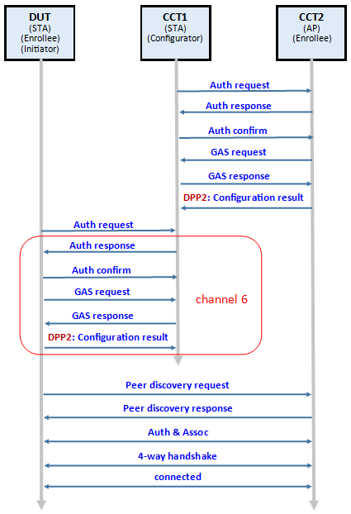
Figure 5. Frame Exchange Flow(QR)
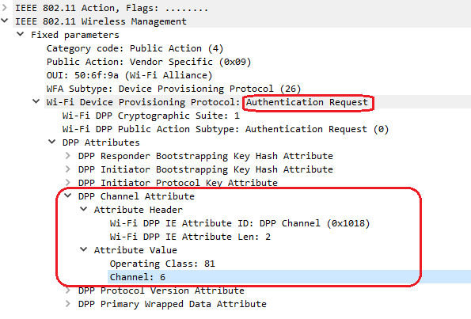
In test, STA uses wpa_supplicant and AP uses hostapd. QR code test steps(values in () represent command returned value. Command in <> represent optional value):
Please refer the test procedure of “4.1 DUT as Enrollee, Initiator(Authentication), enrolled as STA”, and change channel to 1 and dpp_listen on frequency 2412, and change the last step:
Change step 4.1.16. DUT: wlan-dpp-auth-init " peer=1 role=enrollee"
To 16. DUT: wlan-dpp-auth-init " peer=1 role=enrollee neg_freq=2437"

DUT as Enrollee STA, Responder(Authentication), includes Channel attribute during authentication test
The command flow as following. DUT act as responder and enrollee, configured as STA. CTT1 act as configurator. CTT2 act as enrollee, configured as AP.
Refer to “5.1.8 STAUT configured in Enrollee STA role acting as an authentication Responder handles Channel attribute during authentication test” in Wi-Fi_CERTIFIED_Easy_Connect_Test_Plan_v3.0.pdf
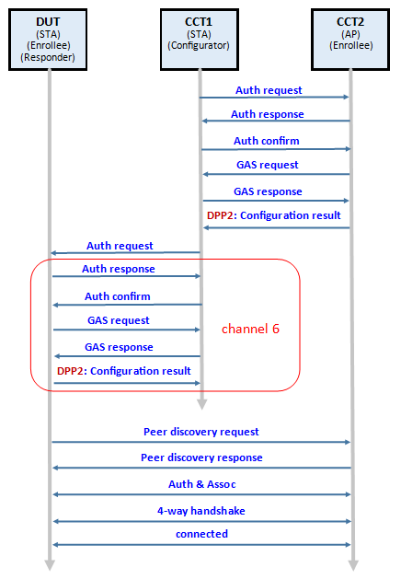
Figure 6. Frame Exchange Flow(QR)



In test, STA uses wpa_supplicant and AP uses hostapd. QR code test steps(values in () represent command returned value. Command in <> represent optional value):
Please refer the test procedure of “4.2 DUT as Enrollee, Responder(Authentication), enrolled as STA”, and change channel to 1 and dpp_listen on frequency 2412, and change the last step:
Change step 4.2.7. CTT1: wlan-dpp-auth-init " peer=1 conf=ap-dpp ssid=4450504e45543031 configurator=< conf_id>"
To 7. CTT1: wlan-dpp-auth-init " peer=1 conf=ap-dpp ssid=4450504e45543031 configurator=< conf_id> neg_freq=2437"

DUT as Enrollee STA, Initiator(Authentication), includes Protocol Version attribute test
The command flow as following. DUT act as initiator and enrollee, configured as STA. CTT1 act as configurator. CTT2 act as enrollee, configured as AP.
Refer to “5.1.9 STAUT configured in Enrollee STA role acting as an authentication Initiator includes Protocol Version attribute test” in Wi-Fi_CERTIFIED_Easy_Connect_Test_Plan_v3.0.pdf

In test, STA uses wpa_supplicant and AP uses hostapd. QR code test steps(values in () represent command returned value. Command in <> represent optional value):
Test procedure is the same “4.1 DUT as Enrollee, Initiator(Authentication), enrolled as STA”.
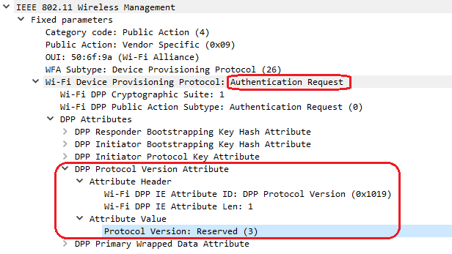

DUT as Enrollee STA, Responder(Authentication), includes Protocol Version attribute test
The command flow as following. DUT act as responder and enrollee, configured as STA. CTT1 act as configurator. CTT2 act as enrollee, configured as AP.
Refer to “5.1.10 STAUT configured in Enrollee STA role acting as an authentication Responder includes Protocol Version attribute test” in Wi-Fi_CERTIFIED_Easy_Connect_Test_Plan_v3.0.pdf
In test, STA uses wpa_supplicant and AP uses hostapd. QR code test steps(values in () represent command returned value. Command in <> represent optional value):
Test procedure is the same “4.2 DUT as Enrollee, Responder(Authentication), enrolled as STA”.


DUT as Enrollee STA and connect by PFS test
The command flow as following. DUT act as initiator/responder and enrollee, configured as STA. CTT1 act as configurator. CTT2 act as enrollee, configured as AP.
Refer to “5.1.15 STAUT configured in Enrollee STA and connect by PFS test” in Wi-Fi_CERTIFIED_Easy_Connect_Test_Plan_v3.0.pdf
In test, STA uses wpa_supplicant and AP uses hostapd. QR code test steps(values in () represent command returned value. Command in <> represent optional value):
Test procedure is the same “4.1 DUT as Enrollee, Initiator(Authentication), enrolled as STA” and “4.2 DUT as Enrollee, Responder(Authentication), enrolled as STA”, and verify that Association Request frame includes the Diffie-Hellman Parameter element.
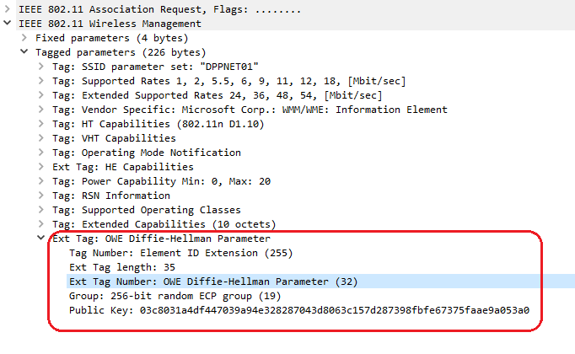

DUT as Enrollee STA, Initiator(Authentication), handles multiple attributes during Configuration test
The command flow as following. DUT act as initiator and enrollee, configured as STA. CTT1 act as configurator. CTT2 act as enrollee, configured as AP.
Refer to “5.1.16 STAUT configured in Enrollee STA role acting as an authentication Initiator handles multiple attributes during Configuration test” in Wi-Fi_CERTIFIED_Easy_Connect_Test_Plan_v3.0.pdf
In test, STA uses wpa_supplicant and AP uses hostapd. QR code test steps(values in () represent command returned value. Command in <> represent optional value):
Test procedure is the same “4.1 DUT as Enrollee, Initiator(Authentication) , enrolled as STA”, and verify that a DPP Configuration Result frame is sent as a Public Action frame with the following attributes present:
• Wrapped data
• DPP Status
• Enrollee Nonce
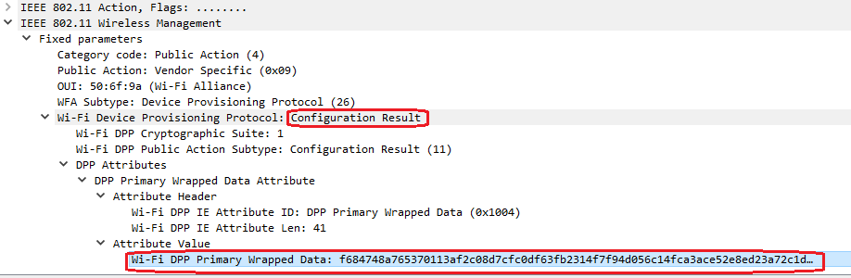
Note: wpa_supplicant wrapped “DPP Status” and “Enrollee Nonce” into a package of DPP Primary Wrapped Data

DUT as Enrollee STA, Responder(Authentication), handles multiple attributes during Configuration test
The command flow as following. DUT act as responder and enrollee, configured as STA. CTT1 act as configurator. CTT2 act as enrollee, configured as AP.
Refer to “5.1.17 STAUT configured in Enrollee STA role acting as an authentication Responder handles multiple attributes during Configuration test” in Wi-Fi_CERTIFIED_Easy_Connect_Test_Plan_v3.0.pdf
In test, STA uses wpa_supplicant and AP uses hostapd. QR code test steps(values in () represent command returned value. Command in <> represent optional value):
Test procedure is the same “4.2 DUT as Enrollee, Responder(Authentication), enrolled as STA”, and verify that a DPP Configuration Result frame is sent as a Public Action frame with the following attributes present:
• Wrapped data
• DPP Status
• Enrollee Nonce

Note: wpa_supplicant wrapped “DPP Status” and “Enrollee Nonce” into a package of DPP Primary Wrapped Data

DUT as Enrollee STA, Reconfiguration test
The command flow as following. DUT act as initiator/responder and enrollee, configured as STA. CTT1 act as configurator. CTT2 act as enrollee, configured as AP.
Refer to “5.1.19 STAUT Reconfiguration test” in Wi-Fi_CERTIFIED_Easy_Connect_Test_Plan_v3.0.pdf
In test, STA uses wpa_supplicant and AP uses hostapd. QR code test steps(values in () represent command returned value. Command in <> represent optional value):
Test procedure is the same “4.1 DUT as Enrollee, Initiator(Authentication), enrolled as STA” and “4.2 DUT as Enrollee, Responder(Authentication), enrolled as STA”. After the DUT is successfully connected to the AP, proceed to the following steps:
- CTT2: wlan-reset 2
- CTT2: wlan-set-mac 00:50:43:02:11:01
- CTT2: wlan-add testAP ssid DPPNET01 ip:192.168.10.1,192.168.10.1,255.255.255.0 role uap channel 11 wpa2 ThisIsDppPassphrase
3. CTT2: wlan-start-network testAP
4. CTT2: wlan-dpp-bootstrap-gen "type=qrcode chan=81/11 mac=00:50:43:02:12:01"
bootstrap generate id = 1
4. CTT2: wlan-dpp-bootstrap-gen "type=qrcode chan=81/11 mac=00:50:43:02:12:01"
5. CTT2: wlan-dpp-bootstrap-get-uri 1
Bootstrapping QR Code URI:
DPP:C:81/11;M:005043021201;V:3;K:……
6. CTT1: wlan-dpp-qr-code DPP:C: 81/11;M:005043021201;V:3;K:……
DPP qr code id = 3
7. CTT1: wlan-dpp-auth-init " peer=3 conf=ap-psk ssid=4450504e45543031 configurator=1 akm_use_selector=1 psk=10506e102ad1e7f95112f6b127675bb8344dacacea60403f3fa4055aec85b0fc"
# follow “Configuration Index 2: Object Parameters for PSK HEX, Infra”
Results:
CTT2: DPP-AUTH-SUCCESS, DPP-CONF-RECEIVED, DPP-CONFOBJ-AKM, DPP-CONFOBJ-SSID, DPP-CONNECTOR, DPP-C-SIGN-KEY, DPP-NET-ACCESS-KEY
CTT1: DPP-AUTH-SUCCESS, DPP-CONF-SENT
8. CTT1: wlan-dpp-configurator-params " conf=sta-psk ssid=4450504e45543031 configurator=1 psk=10506e102ad1e7f95112f6b127675bb8344dacacea60403f3fa4055aec85b0fc"
9. DUT: wlan-dpp-reconfig 1
Results:
DUT: DPP-AUTH-SUCCESS, DPP-CONF-RECEIVED, DPP-CONFOBJ-SSID, DPP-CONNECTOR, DPP-C-SIGN-KEY, DPP-NET-ACCESS-KEY
CTT1: DPP-AUTH-SUCCESS, DPP-CONF-SENT

Connection between DUT and CTT2 success and ping can work for more than 30 seconds.

DUT as Enrollee STA, sends DPP presence announcement test
The command flow as following. DUT act as initiator/responder and enrollee, configured as STA. CTT1 act as configurator. CTT2 act as enrollee, configured as AP.
Refer to “5.1.20 STAUT sends DPP presence announcement test” in Wi-Fi_CERTIFIED_Easy_Connect_Test_Plan_v3.0.pdf
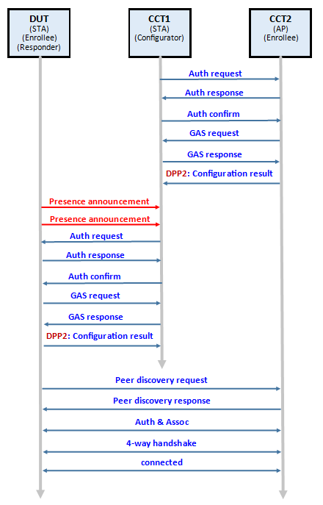
Figure 7. Frame Exchange Flow(QR)

In test, STA uses wpa_supplicant and AP uses hostapd. QR code test steps(values in () represent command returned value. Command in <> represent optional value):
Test procedure is the same as “4.2 DUT as Enrollee, Responder(Authentication), enrolled as STA” and change some steps after 4.2.5 DUT: wlan-dpp-listen "2462 role=enrollee".
- DUT: wlan-dpp-chirp " own=1 listen=2462"
# Send presence announcement frame
# Wait 20 seconds and then CTT1 sets DUT's bootstrapping URI.
- CTT1: wlan-dpp-qr-code DPP:C:81/11;M:005043021201;V:3;K:……
- DUT: wlan-dpp-chirp " own=1 listen=2462"
# Send presence announcement frame again.
Results:
DUT: DPP-CONF-RECEIVED, DPP-CONFOBJ-AKM, DPP-CONFOBJ-SSID, DPP-CONNECTOR, DPP-C-SIGN-KEY, DPP-PP-KEY, DPP-NET-ACCESS-KEY
CTT1: DPP-AUTH-SUCCESS, DPP-CONF-SENT
Connection between DUT and CTT2 success and ping can work for more than 30 seconds.

DUT as Enrollee STA, Initiator(Authentication), and sends the MUD URL
The command flow is as following. DUT act as initiator and enrollee, configured as STA. CTT1 act as configurator. CTT2 act as enrollee, configured as AP.
Refer to “5.1.23 STAUT sends the MUD URL” in Wi-Fi_CERTIFIED_Easy_Connect_Test_Plan_v3.0.pdf
In test, STA uses wpa_supplicant and AP uses hostapd. QR code test steps(values in () represent command returned value. Command in <> represent optional value):
- CTT1: wlan-set-mac 00:50:43:02:11:03
- CTT1: wlan-dpp-configurator-add
- CTT1: wlan-dpp-configurator-params " conf=sta-dpp ssid=<hex_ascii> configurator=< conf_id>"
# space character exists between “ & conf word.
- CTT1: wlan-dpp-bootstrap-gen "type=qrcode chan=81/1 mac=00:50:43:02:11:03"
- CTT1: wlan-dpp-bootstrap-get-uri <bootstrap_id>
Bootstrapping QR Code URI:
DPP:C:81/11;M:005043021103;V:3;K:…….
- CTT1: wlan-dpp-listen "2462 role=configurator"
- DUT: wlan-set-mac 00:50:43:02:11:02
- wlan-dpp-mud-url "https://example.com/mud"
- DUT: wlan-dpp-qr-code DPP:C:81/11;M:005043021103;V:3;K:……….
DPP qr code id = 1
- DUT: wlan-dpp-auth-init " peer=1 role=enrollee"
Results:
CTT1: DPP-AUTH-SUCCESS, DPP-MUD-URL https://example.com/mud, DPP-CONF-SENT
DUT: DPP-AUTH-SUCCESS, DPP-CONF-RECEIVED, DPP-CONFOBJ-SSID, DPP-CONNECTOR, DPP-C-SIGN-KEY, DPP-NET-ACCESS-KEY

DUT as Enrollee STA, Initiator(Authentication), handles DPP Connection Status Result test
The command flow is as following. DUT act as initiator and enrollee, configured as STA. CTT1 act as configurator. CTT2 act as enrollee, configured as AP.
Refer to “5.1.24 STAUT handles DPP Connection Status Result test” in Wi-Fi_CERTIFIED_Easy_Connect_Test_Plan_v3.0.pdf
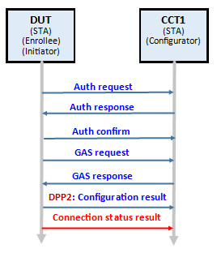
Figure 8. Frame Exchange Flow(QR)
In test, STA uses wpa_supplicant and AP uses hostapd. QR code test steps(values in () represent command returned value. Command in <> represent optional value):
- CTT1: wlan-set-mac 00:50:43:02:11:03
- CTT1: wlan-dpp-configurator-add
- CTT1: wlan-dpp-configurator-params " conf=sta-dpp ssid=<hex_ascii> configurator=< conf_id> conn_status=1"
# space character exists between “ & conf word.
- CTT1: wlan-dpp-bootstrap-gen "type=qrcode chan=81/1 mac=00:50:43:02:11:03"
- CTT1: wlan-dpp-bootstrap-get-uri <bootstrap_id>
Bootstrapping QR Code URI:
DPP:C:81/11;M:005043021103;V:3;K:…….
- CTT1: wlan-dpp-listen "2462 role=configurator"
- DUT: wlan-set-mac 00:50:43:02:11:02
- DUT: wlan-dpp-qr-code DPP:C:81/11;M:005043021103;V:3;K:……….
DPP qr code id = 1
- DUT: wlan-dpp-auth-init " peer=1 role=enrollee"
Results:
CTT1: DPP-AUTH-SUCCESS, DPP-CONF-SENT, DPP-CONN-STATUS-RESULT
DUT: DPP-AUTH-SUCCESS, DPP-CONF-RECEIVED, DPP-CONFOBJ-SSID, DPP-CONNECTOR, DPP-C-SIGN-KEY, DPP-NET-ACCESS-KEY

DUT as Enrollee STA, reconfiguration using different bootstrapping key and signing key elliptical curves test
The command flow as following. DUT act as initiator/responder and enrollee, configured as STA. CTT1 act as configurator. CTT2 act as enrollee, configured as AP.
Refer to “5.1.25 STAUT Reconfiguration using different bootstrapping key and signing key elliptical curves test” in Wi-Fi_CERTIFIED_Easy_Connect_Test_Plan_v3.0.pdf
In test, STA uses wpa_supplicant and AP uses hostapd. QR code test steps(values in () represent command returned value. Command in <> represent optional value):
Determine the complexity of the elliptical curve according to the capability of the HW accelerator, he length of the elliptical curve will affect the operation time, resulting in DPP protocol timeout and failed.
DUT Authentication Role is initiator:
Please refer the test procedure of “4.1 DUT as Enrollee, Initiator(Authentication), enrolled as STA” and “4.13 DUT as Enrollee STA, Reconfiguration test”, and change channel to 1 and change some steps:
Change step 4.1.7. CTT1: wlan-dpp-configurator-add
To 7. CTT1: wlan-dpp-configurator-add " curve=P-384"
# space character exists between “ & curve= word.
Change step 4.1.11. CTT1: wlan-dpp-bootstrap-gen "type=qrcode chan=81/11 mac=00:50:43:02:11:03"
To 11. CTT1: wlan-dpp-bootstrap-gen "type=qrcode chan=81/1 mac=00:50:43:02:11:03 curve=P-256"

DUT Authentication Role is responder:
Please refer the test procedure of “4.2 DUT as Enrollee, Responder(Authentication), enrolled as STA” and “4.13 DUT as Enrollee STA, Reconfiguration test”, and change channel to 1, and change some steps:
Change step 4.1.7. CTT1: wlan-dpp-configurator-add
To 7. CTT1: wlan-dpp-configurator-add " curve=P-384"
# space character exists between “ & curve= word.
Change step 4.2.3. DUT: wlan-dpp-bootstrap-gen "type=qrcode chan=81/11 mac=00:50:43:02:11:02"
To 3. DUT: wlan-dpp-bootstrap-gen "type=qrcode chan=81/1 mac=00:50:43:02:11:02 curve=P-256"

DUT as Enrollee STA, configured using different elliptical curves for NAK and bootstrapping key test
The command flow as following. DUT act as initiator/responder and enrollee, configured as STA. CTT1 act as configurator. CTT2 act as enrollee, configured as AP.
Refer to “5.1.25 STAUT Reconfiguration using different bootstrapping key and signing key elliptical curves test” in Wi-Fi_CERTIFIED_Easy_Connect_Test_Plan_v3.0.pdf
In test, STA uses wpa_supplicant and AP uses hostapd. QR code test steps(values in () represent command returned value. Command in <> represent optional value):
Determine the complexity of the elliptical curve according to the capability of the HW accelerator, he length of the elliptical curve will affect the operation time, resulting in DPP protocol timeout and failed.
DUT Authentication Role is initiator:
Please refer the test procedure of “4.1 DUT as Enrollee, Initiator(Authentication), enrolled as STA” and “4.13 DUT as Enrollee STA, Reconfiguration test”, and change some steps:
Change step 4.1.7. CTT1: wlan-dpp-configurator-add
To 7. CTT1: wlan-dpp-configurator-add " net_access_key_curve=P-256"
# space character exists between “ & curve= word.
Change step 4.1.10. CTT1: wlan-dpp-configurator-params " conf=sta-dpp ssid=<hex_ascii> configurator=< conf_id>"
To 10. CTT1: wlan-dpp-configurator-params " conf=sta-dpp ssid=<hex_ascii> configurator=< conf_id> net_access_key_curve=P-256"
Change step 4.1.11. CTT1: wlan-dpp-bootstrap-gen "type=qrcode chan=81/11 mac=00:50:43:02:11:03"
To 11. CTT1: wlan-dpp-bootstrap-gen "type=qrcode chan=81/11 mac=00:50:43:02:11:03 curve=BP-384"

DUT Authentication Role is responder:
Please refer the test procedure of “4.2 DUT as Enrollee, Responder(Authentication), enrolled as STA” and “4.13 DUT as Enrollee STA, Reconfiguration test”, and change some steps:
Change step 4.1.7. CTT1: wlan-dpp-configurator-add
To 7. CTT1: wlan-dpp-configurator-add " net_access_key_curve=P-256"
# space character exists between “ & curve= word.
Change step 4.1.10. CTT1: wlan-dpp-configurator-params " conf=sta-dpp ssid=<hex_ascii> configurator=< conf_id>"
To 10. CTT1: wlan-dpp-configurator-params " conf=sta-dpp ssid=<hex_ascii> configurator=< conf_id> net_access_key_curve=P-256"
Change step 4.2.3. DUT: wlan-dpp-bootstrap-gen "type=qrcode chan=81/11 mac=00:50:43:02:11:02"
To 3. DUT: wlan-dpp-bootstrap-gen "type=qrcode chan=81/11 mac=00:50:43:02:11:02 curve=BP-384"

APUT test case

DUT as Enrollee, Initiator(Authentication), enrolled as AP
The command flow is as following. DUT act as initiator and enrollee, configured as AP. CTT1 act as configurator. CTT2 act as enrollee, configured as STA.
Refer to “5.2.1 APUT configured in Enrollee AP role acts as an authentication Initiator test” in Wi-Fi_CERTIFIED_Easy_Connect_Test_Plan_v3.0.pdf
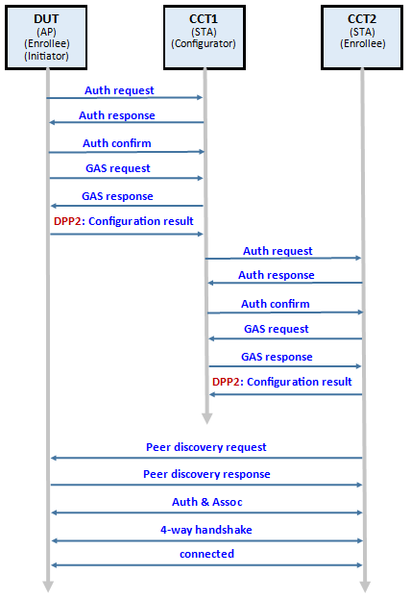
Figure 9. Frame Exchange Flow(QR)

- CTT1: wlan-set-mac 00:50:43:02:11:03
- CTT1: wlan-dpp-configurator-add
- CTT1: wlan-dpp-configurator-params " conf=ap-dpp ssid=4450504e45543031 configurator=1"
- CTT1: wlan-dpp-bootstrap-gen "type=qrcode chan=81/6,81/11 mac=00:50:43:02:11:03"
# Support multi channel list in URI
- CTT1: wlan-dpp-bootstrap-get-uri 1
- CTT1: wlan-dpp-listen "2462 role=configurator"
- DUT: wlan-set-mac 00:50:43:02:11:01
- DUT: wlan-add testAP ssid DPPNET01 ip:192.168.10.1,192.168.10.1,255.255.255.0 role uap channel 11 wpa2 ThisIsDppPassphrase
- DUT: wlan-start-network testAP
- DUT: wlan-dpp-qr-code DPP:C: 81/11;M:005043021103;V:3;K:……
- DUT: wlan-dpp-auth-init " peer=1 role=enrollee"
Results:
DUT: DPP-AUTH-SUCCESS, DPP-CONF-RECEIVED, DPP-CONFOBJ-AKM, DPP-CONFOBJ-SSID, DPP-CONNECTOR, DPP-C-SIGN-KEY, DPP-NET-ACCESS-KEY
CTT1: DPP-AUTH-SUCCESS, DPP-CONF-SENT
- CTT2: wlan-set-mac 00:50:43:02:11:02
- CTT2: wlan-dpp-bootstrap-gen "type=qrcode chan=81/11 mac=00:50:43:02:11:02"
- CTT2: wlan-dpp-bootstrap-get-uri 1
- CTT2: wlan-dpp-listen "2462 role=enrollee"
- CTT1: wlan-dpp-qr-code DPP:C:81/11;M:005043021102;V:3;K:……
- CTT1: wlan-dpp-auth-init " peer=2 conf=sta-dpp ssid=4450504e45543031 configurator=1"
Results:
CCT2: DPP-AUTH-SUCCESS, DPP-CONF-RECEIVED, DPP-CONFOBJ-SSID, DPP-CONNECTOR, DPP-C-SIGN-KEY, DPP-NET-ACCESS-KEY
CTT1: DPP-AUTH-SUCCESS, DPP-CONF-SENT
Connection between DUT and CTT2 success and ping can work for more than 30 seconds.

DUT as Enrollee, Responder(Authentication), enrolled as AP
The command flow is as following. DUT act as responder and enrollee, configured as AP. CTT1 act as configurator. CTT2 act as enrollee, configured as STA.
Refer to “5.2.2 APUT configured in Enrollee AP role acts as an authentication Responder test” in Wi-Fi_CERTIFIED_Easy_Connect_Test_Plan_v3.0.pdf
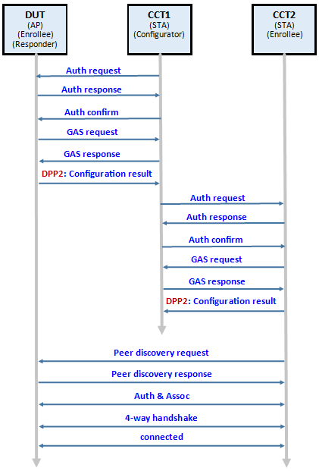
Figure 10. Frame Exchange Flow(QR)

- DUT: wlan-set-mac 00:50:43:02:11:01
- DUT: wlan-add testAP ssid DPPNET01 ip:192.168.10.1,192.168.10.1,255.255.255.0 role uap channel 11 wpa2 ThisIsDppPassphrase
- DUT: wlan-start-network testAP
- DUT: wlan-dpp-bootstrap-gen "type=qrcode chan=81/11 mac=00:50:43:02:12:01"
- DUT: wlan-dpp-bootstrap-get-uri 1
- CTT1: wlan-set-mac 00:50:43:02:11:03
- CTT1: wlan-dpp-configurator-add
- CTT1: wlan-dpp-qr-code DPP:C:81/11;M:005043021201;V:3;K:……
- wlan-dpp-auth-init " peer=1 conf=ap-dpp ssid=4450504e45543031 configurator=1"
Or for 5.2.2.1J and K, check that the Beacon frame has the expected AKMs which would be DPP, SAE, and if supported PSK.
wlan-dpp-auth-init " peer=1 conf=ap-psk-sae-dpp ssid=4450504e45543031 configurator=1 akm_use_selector=1 pass=54686973497344707050617373706872617365 psk=10506e102ad1e7f95112f6b127675bb8344dacacea60403f3fa4055aec85b0fc"
Results:
DUT: DPP-AUTH-SUCCESS, DPP-CONF-RECEIVED, DPP-CONFOBJ-AKM, DPP-CONFOBJ-SSID, DPP-CONNECTOR, DPP-C-SIGN-KEY, DPP-NET-ACCESS-KEY
CTT1: DPP-AUTH-SUCCESS, DPP-CONF-SENT
- CTT2: wlan-set-mac 00:50:43:02:11:02
- CTT2: wlan-dpp-bootstrap-gen "type=qrcode chan=81/11 mac=00:50:43:02:11:02"
- CTT2: wlan-dpp-bootstrap-get-uri 1
- CTT2: wlan-dpp-listen "2462 role=enrollee"
- CTT1: wlan-dpp-qr-code DPP:C:81/11;M:005043021102;V:3;K:……
- CTT1: wlan-dpp-auth-init " peer=2 conf=sta-dpp ssid=4450504e45543031 configurator=1"
Or for 5.2.2.1F_P256, verify that the Association Request frame is using the SAE AKM.
wlan-dpp-auth-init " peer=2 conf=sta-sae ssid=4450504e45543031 configurator=1 pass=54686973497344707050617373706872617365"
Results:
CCT2: DPP-AUTH-SUCCESS, DPP-CONF-RECEIVED, DPP-CONFOBJ-SSID, DPP-CONNECTOR, DPP-C-SIGN-KEY, DPP-NET-ACCESS-KEY
CTT1: DPP-AUTH-SUCCESS, DPP-CONF-SENT
Connection between DUT and CTT2 success and ping can work for more than 30 seconds.

DUT as Enrollee AP, using different bootstrapping key and signing key elliptical curve test
The command flow is as following. DUT act as initiator/responder and enrollee, configured as AP. CTT1 act as configurator. CTT2 act as enrollee, configured as STA.
Refer to “5.2.3 APUT configured as Enrollee AP using different bootstrapping key and signing key elliptical curve test” in Wi-Fi_CERTIFIED_Easy_Connect_Test_Plan_v3.0.pdf
Determine the complexity of the elliptical curve according to the capability of the HW accelerator, he length of the elliptical curve will affect the operation time, resulting in DPP protocol timeout and failed.
DUT Authentication Role is initiator(5.2.3_I_P256_P384):
Please refer the test procedure of “5.1 DUT as Enrollee, Initiator(Authentication), enrolled as AP”, and change some steps:
Change step
5.1.2. CTT1: wlan-dpp-configurator-add
To
2. CTT1: wlan-dpp-configurator-add " curve=P-384"
Change step
5.1.4. CCT1: wlan-dpp-bootstrap-gen "type=qrcode chan=81/6,81/11 mac=00:50:43:02:11:03"
To
4. CTT1: wlan-dpp-bootstrap-gen "type=qrcode chan=81/11 mac=00:50:43:02:11:03 curve=P-256"

DUT Authentication Role is responder(5.2.3_R_P256_P384):
Please refer the test procedure of “5.2 DUT as Enrollee, Responder(Authentication), enrolled as AP”, and change some steps:
Change step
5.2.4. DUT: wlan-dpp-bootstrap-gen "type=qrcode chan=81/11 mac=00:50:43:02:12:01"
To
4. DUT: wlan-dpp-bootstrap-gen "type=qrcode chan=81/11 mac=00:50:43:02:12:01 curve=P-256"
Change step
5.2.7. CTT1: wlan-dpp-configurator-add
To
7. CTT1: wlan-dpp-configurator-add " curve=P-384"

DUT as Enrollee AP, Initiator(Authentication), handles STATUS_RESPONSE_PENDING during authentication test
The command flow is as following. DUT act as initialtor and enrollee, configured as AP. CTT1 act as configurator. CTT2 act as enrollee, configured as STA.
Refer to “5.2.4 APUT configured in Enrollee AP role acting as an authentication Initiator handles STATUS_RESPONSE_PENDING during authentication test” in Wi-Fi_CERTIFIED_Easy_Connect_Test_Plan_v3.0.pdf
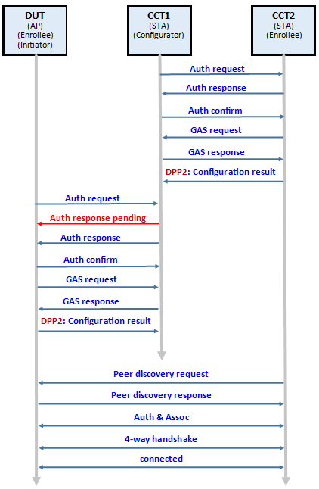
Figure 11. Frame Exchange Flow(QR)

- CTT2: wlan-set-mac 00:50:43:02:11:02
- CTT2: wlan-dpp-bootstrap-gen "type=qrcode chan=81/11 mac=00:50:43:02:11:02"
- CTT2: wlan-dpp-bootstrap-get-uri 1
- CTT2: wlan-dpp-listen "2462 role=enrollee"
- CTT1: wlan-set-mac 00:50:43:02:11:03
- CTT1: wlan-dpp-configurator-add
- CTT1: wlan-dpp-qr-code DPP:C:81/11;M:005043021102;V:3;K:……
- CTT1: wlan-dpp-auth-init " peer=1 conf=sta-dpp ssid=4450504e45543031 configurator=1"
Results:
CCT2: DPP-AUTH-SUCCESS, DPP-CONF-RECEIVED, DPP-CONFOBJ-AKM, DPP-CONFOBJ-SSID, DPP-CONNECTOR, DPP-C-SIGN-KEY, DPP-NET-ACCESS-KEY
CTT1: DPP-AUTH-SUCCESS, DPP-CONF-SENT
- CTT1: wlan-dpp-configurator-params " conf=ap-dpp ssid=4450504e45543031 configurator=1"
- CTT1: wlan-dpp-bootstrap-gen "type=qrcode chan=81/11 mac=00:50:43:02:11:03"
- CTT1: wlan-dpp-bootstrap-get-uri 2
- CTT1: wlan-dpp-listen "2462 role=configurator qr=mutual"
- DUT: wlan-set-mac 00:50:43:02:11:01
- DUT: wlan-add testAP ssid DPPNET01 ip:192.168.10.1,192.168.10.1,255.255.255.0 role uap channel 11 wpa2 ThisIsDppPassphrase
- DUT: wlan-start-network testAP
- DUT: wlan-dpp-qr-code DPP:C:81/11;M:005043021103;V:3;K:……
- DUT: wlan-dpp-auth-init " peer=1 role=enrollee"
Wait to see the string in console “DPP-RESPONSE-PENDING DPP:V:3;K:……;;”
- CTT1: wlan-dpp-qr-code DPP:V:3;K:……;;
Results:
DUT: DPP-AUTH-SUCCESS, DPP-CONF-RECEIVED, DPP-CONFOBJ-SSID, DPP-CONNECTOR, DPP-C-SIGN-KEY, DPP-NET-ACCESS-KEY
CTT1: DPP-AUTH-SUCCESS, DPP-CONF-SENT
Connection between DUT and CTT2 success and ping can work for more than 30 seconds.

DUT as Enrollee AP, Responder(Authentication), handles STATUS_RESPONSE_PENDING during authentication test
The command flow is as following. DUT act as responder and enrollee, configured as AP. CTT1 act as configurator. CTT2 act as enrollee, configured as STA.
Refer to “5.2.5 APUT configured in Enrollee AP role acting as an authentication Responder sends STATUS_RESPONSE_PENDING during authentication test” in Wi-Fi_CERTIFIED_Easy_Connect_Test_Plan_v3.0.pdf
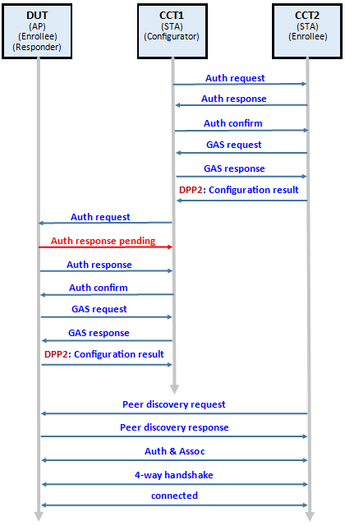
Figure 12. Frame Exchange Flow(QR)

- CTT2: wlan-set-mac 00:50:43:02:11:02
- CTT2: wlan-dpp-bootstrap-gen "type=qrcode chan=81/11 mac=00:50:43:02:11:02"
- CTT2: wlan-dpp-bootstrap-get-uri 1
- CTT2: wlan-dpp-listen "2462 role=enrollee"
- CTT1: wlan-set-mac 00:50:43:02:11:03
- CTT1: wlan-dpp-configurator-add
- CTT1: wlan-dpp-qr-code DPP:C:81/11;M:005043021102;V:3;K:……
- CTT1: wlan-dpp-auth-init " peer=1 conf=sta-dpp ssid=4450504e45543031 configurator=1"
Results:
CCT2: DPP-AUTH-SUCCESS, DPP-CONF-RECEIVED, DPP-CONFOBJ-AKM, DPP-CONFOBJ-SSID, DPP-CONNECTOR, DPP-C-SIGN-KEY, DPP-NET-ACCESS-KEY
CTT1: DPP-AUTH-SUCCESS, DPP-CONF-SENT
- DUT: wlan-set-mac 00:50:43:02:11:01
- DUT: wlan-add testAP ssid DPPNET01 ip:192.168.10.1,192.168.10.1,255.255.255.0 role uap channel 11 wpa2 ThisIsDppPassphrase
- DUT: wlan-start-network testAP
- DUT: wlan-start-network testAP
- DUT: wlan-dpp-bootstrap-gen "type=qrcode chan=81/6,81/11 mac=00:50:43:02:12:01"
- DUT: wlan-dpp-bootstrap-get-uri 1
- DUT: wlan-dpp-listen "2462 role=enrollee qr=mutual"
- CTT1: wlan-dpp-qr-code DPP:C:81/11;M:005043021201;V:3;K:……
- CTT1: wlan-dpp-auth-init " peer=2 conf=ap-dpp ssid=4450504e45543031 configurator=1"
# Wait to see the string in console “DPP-RESPONSE-PENDING DPP:V:3;K:……;;”
- DUT: wlan-dpp-qr-code DPP:V:3;K:……;;
Results:
DUT: DPP-AUTH-SUCCESS, DPP-CONF-RECEIVED, DPP-CONFOBJ-SSID, DPP-CONNECTOR, DPP-C-SIGN-KEY, DPP-NET-ACCESS-KEY
CTT1: DPP-AUTH-SUCCESS, DPP-CONF-SENT
Connection between DUT and CTT2 success and ping can work for more than 30 seconds.

DUT as Enrollee AP, Initiator(Authentication), includes Channel attribute during authentication test
Refer to “5.2.7 APUT configured in Enrollee AP role acting as an authentication Initiator includes Channel attribute during authentication test” in Wi-Fi_CERTIFIED_Easy_Connect_Test_Plan_v3.0.pdf
(hostapd does not yet support)

DUT as Enrollee AP, Initiator(Authentication), includes Channel attribute during authentication test
Refer to “5.2.8 APUT configured in Enrollee AP role acting as an authentication Responder handles Channel attribute during authentication test” in Wi-Fi_CERTIFIED_Easy_Connect_Test_Plan_v3.0.pdf
(hostapd does not yet support)

DUT as Enrollee AP, Initiator(Authentication), includes Protocol Version attribute test
The command flow is as following. DUT act as initiator and enrollee, configured as AP. CTT1 act as configurator. CTT2 act as enrollee, configured as STA.
Refer to “5.2.9 APUT configured in Enrollee AP role acting as an authentication Initiator includes Protocol Version attribute test” in Wi-Fi_CERTIFIED_Easy_Connect_Test_Plan_v3.0.pdf
Test procedure is the same “5.1 DUT as Enrollee, Initiator(Authentication), enrolled as AP”.


DUT as Enrollee AP, Responder(Authentication), includes Protocol Version attribute test
The command flow is as following. DUT act as responder and enrollee, configured as AP. CTT1 act as configurator. CTT2 act as enrollee, configured as STA.
Refer to “5.2.10 APUT configured in Enrollee AP role acting as an authentication Responder includes Protocol Version attribute test” in Wi-Fi_CERTIFIED_Easy_Connect_Test_Plan_v3.0.pdf
Test procedure is the same “5.2 DUT as Enrollee, Responder(Authentication), enrolled as AP”.
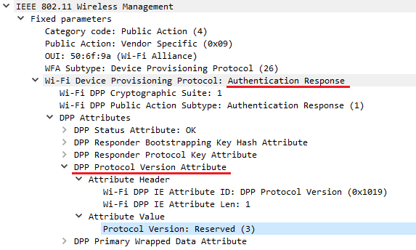

DUT as Enrollee AP and connect by PFS test
The command flow is as following. DUT act as responder and enrollee, configured as AP. CTT1 act as configurator. CTT2 act as enrollee, configured as STA.
Refer to “5.2.15 APUT configured in Enrollee AP and connect by PFS test” in Wi-Fi_CERTIFIED_Easy_Connect_Test_Plan_v3.0.pdf
Test procedure is the same “5.1 DUT as Enrollee, Initiator(Authentication), enrolled as AP” and “5.2 DUT as Enrollee, Responder(Authentication), enrolled as AP”, and verify that Association Request frame includes the Diffie-Hellman Parameter element.


DUT as Enrollee AP, Initiator(Authentication), handles multiple attributes during Configuration test
The command flow is as following. DUT act as initiator and enrollee, configured as AP. CTT1 act as configurator. CTT2 act as enrollee, configured as STA.
Refer to “5.2.16 APUT configured in Enrollee AP role acting as an authentication Initiator handles multiple attributes during Configuration test” in Wi-Fi_CERTIFIED_Easy_Connect_Test_Plan_v3.0.pdf
Test procedure is the same “5.1 DUT as Enrollee, Initiator(Authentication) , enrolled as AP”, and verify that a DPP Configuration Result frame is sent as a Public Action frame with the following attributes present:
• Wrapped data
• DPP Status
• Enrollee Nonce

Note: wpa_supplicant wrapped “DPP Status” and “Enrollee Nonce” into a package of DPP Primary Wrapped Data

DUT as Enrollee AP, Responder(Authentication), handles multiple attributes during Configuration test
The command flow as following. DUT act as responder and enrollee, configured as AP. CTT1 act as configurator. CTT2 act as enrollee, configured as STA.
Refer to “5.2.17 APUT configured in Enrollee AP role acting as an authentication Responder handles multiple attributes during Configuration test” in Wi-Fi_CERTIFIED_Easy_Connect_Test_Plan_v3.0.pdf
Test procedure is the same “5.2 DUT as Enrollee, Responder(Authentication), enrolled as AP”, and verify that a DPP Configuration Result frame is sent as a Public Action frame with the following attributes present:
• Wrapped data
• DPP Status
• Enrollee Nonce

Note: wpa_supplicant wrapped “DPP Status” and “Enrollee Nonce” into a package of DPP Primary Wrapped Data

DUT as Enrollee AP, sends DPP presence announcement test
The command flow as following. DUT act as initiator/responder and enrollee, configured as AP. CTT1 act as configurator. CTT2 act as enrollee, configured as STA.
Refer to “5.2.18 APUT sends DPP presence announcement test” in Wi-Fi_CERTIFIED_Easy_Connect_Test_Plan_v3.0.pdf
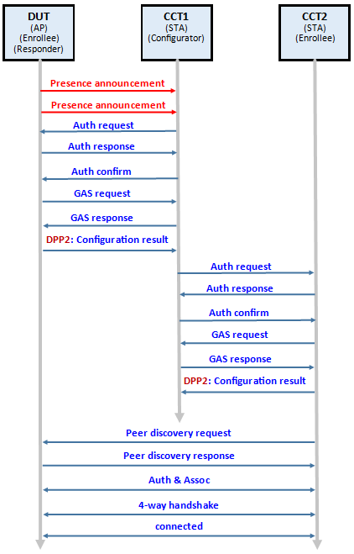
Figure 13. Frame Exchange Flow(QR)

Test procedure is the same as “5.2 DUT as Enrollee, Responder(Authentication), enrolled as AP” and add some steps after 5.2.5 DUT: wlan-dpp-bootstrap-get-uri 1.
6. DUT: wlan-dpp-chirp " own=1 listen=2462"
# Send presence announcement frame
# Wait 20 seconds and then CTT1 sets DUT's bootstrapping URI.
7. CTT1: wlan-set-mac 00:50:43:02:11:03
8. CTT1: wlan-dpp-configurator-add
9. CTT1: wlan-dpp-configurator-params " conf=ap-dpp ssid=4450504e45543031 configurator=1"
10. CTT1: wlan-dpp-qr-code DPP:C:81/11;M:005043021201;V:3;K:……
11. DUT: wlan-dpp-chirp " own=1 listen=2462"
# Send presence announcement frame again.
Results:
DUT: DPP-CONF-RECEIVED, DPP-CONFOBJ-AKM, DPP-CONFOBJ-SSID, DPP-CONNECTOR, DPP-C-SIGN-KEY, DPP-PP-KEY, DPP-NET-ACCESS-KEY
CTT1: DPP-AUTH-SUCCESS, DPP-CONF-SENT
12. Continue 5.2.10 to end.
Connection between DUT and CTT2 success and ping can work for more than 30 seconds.

DUT as Enrollee AP, Initiator(Authentication), and sends the MUD URL
The command flow as following. DUT act as initiator and enrollee, configured as AP. CTT1 act as configurator. CTT2 act as enrollee, configured as STA.
Refer to “5.2.21 APUT sends the MUD URL test” in Wi-Fi_CERTIFIED_Easy_Connect_Test_Plan_v3.0.pdf
Test procedure is the same as step 5.1.1~5.1.11 of “5.1 DUT as Enrollee, initiator(Authentication), enrolled as AP” and add one step between 5.1.9 and 5.1.10:
11. DUT: wlan-dpp-mud-url "https://example.com/mud"
……
Results:
CTT1: DPP-AUTH-SUCCESS, DPP-MUD-URL https://example.com/mud, DPP-CONF-SENT
DUT: DPP-AUTH-SUCCESS, DPP-CONF-RECEIVED, DPP-CONFOBJ-SSID, DPP-CONNECTOR, DPP-C-SIGN-KEY, DPP-NET-ACCESS-KEY

DUT as Enrollee AP, configured using different elliptical curves for NAK and bootstrapping key test
The command flow as following. DUT act as initiator and enrollee, configured as AP. CTT1 act as configurator. CTT2 act as enrollee, configured as STA.
Refer to “5.2.23 APUT configured using different elliptical curves for NAK and bootstrapping key test” in Wi-Fi_CERTIFIED_Easy_Connect_Test_Plan_v3.0.pdf
Determine the complexity of the elliptical curve according to the capability of the HW accelerator, he length of the elliptical curve will affect the operation time, resulting in DPP protocol timeout and failed.
DUT Authentication Role is initiator(5.2.23_BP384_P256):
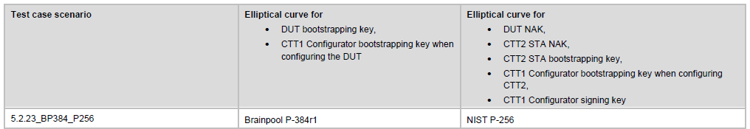
Please refer the test procedure of “5.1 DUT as Enrollee, Initiator(Authentication), enrolled as AP”, and change some steps:
Change step
5.1.2. CTT1: wlan-dpp-configurator-add
To
2. CTT1: wlan-dpp-configurator-add " net_access_key_curve=P-256 curve=P-256"
# space character exists between “ & curve= word.
Change step
5.1.4. CTT1: wlan-dpp-bootstrap-gen "type=qrcode chan=81/11 mac=00:50:43:02:11:03"
To
4. CTT1: wlan-dpp-bootstrap-gen "type=qrcode chan=81/11 mac=00:50:43:02:11:03 curve=BP-384"

COUT test case

COUT configures an Enrollee STA and acts as an authentication Initiator test
The command flow is as following. DUT act as initiator and configurator. CTT act as enrollee, configured as STA.
Refer to “5.3.1 COUT configures an Enrollee STA and acts as an authentication Initiator test” in Wi-Fi_CERTIFIED_Easy_Connect_Test_Plan_v3.0.pdf
- CTT: wlan-set-mac 00:50:43:02:11:02
- CTT: wlan-dpp-bootstrap-gen "type=qrcode chan=81/11 mac=00:50:43:02:11:02"
- CTT: wlan-dpp-bootstrap-get-uri 1
- CTT: wlan-dpp-listen "2462 role=enrollee"
- DUT: wlan-set-mac 00:50:43:02:11:03
- DUT: wlan-dpp-configurator-add
- DUT: wlan-dpp-qr-code DPP:C: 81/11;M:005043021102;V:3;K:……
- DUT: wlan-dpp-auth-init " peer=1 conf=sta-dpp ssid=4450504e45543031 configurator=1"
Results:
CTT: DPP-AUTH-SUCCESS, DPP-CONF-RECEIVED, DPP-CONFOBJ-AKM, DPP-CONFOBJ-SSID, DPP-CONNECTOR, DPP-C-SIGN-KEY, DPP-NET-ACCESS-KEY
DUT: DPP-AUTH-SUCCESS, DPP-CONF-SENT

COUT configures an Enrollee AP and acts as an authentication Initiator test
The command flow is as following. DUT act as initiator and configurator. CTT act as enrollee, configured as AP.
Refer to “5.3.2 COUT configures an Enrollee AP and acts as an authentication Initiator test” in Wi-Fi_CERTIFIED_Easy_Connect_Test_Plan_v3.0.pdf
- CTT: wlan-set-mac 00:50:43:02:11:01
- CTT: wlan-add testAP ssid DPPNET01 ip:192.168.10.1,192.168.10.1,255.255.255.0 role uap channel 11 wpa2 ThisIsDppPassphrase
- CTT: wlan-start-network testAP
- CTT: wlan-dpp-bootstrap-gen "type=qrcode chan=81/11 mac=00:50:43:02:12:01"
- CTT: wlan-dpp-bootstrap-get-uri 1
- DUT: wlan-set-mac 00:50:43:02:11:03
- DUT: wlan-dpp-configurator-add
- DUT: wlan-dpp-qr-code DPP:C: 81/11;M:005043021201;V:3;K:……
- DUT: wlan-dpp-auth-init " peer=1 conf=ap-dpp ssid=4450504e45543031 configurator=1"
Results:
CTT: DPP-AUTH-SUCCESS, DPP-CONF-RECEIVED, DPP-CONFOBJ-AKM, DPP-CONFOBJ-SSID, DPP-CONNECTOR, DPP-C-SIGN-KEY, DPP-NET-ACCESS-KEY
DUT: DPP-AUTH-SUCCESS, DPP-CONF-SENT

COUT configures an Enrollee STA and acts as an authentication Responder test
The command flow is as following. DUT act as responder and configurator. CTT act as enrollee, configured as STA.
Refer to “5.3.3 COUT configures an Enrollee STA and acts as an authentication Responder test” in Wi-Fi_CERTIFIED_Easy_Connect_Test_Plan_v3.0.pdf
- DUT: wlan-set-mac 00:50:43:02:11:03
- DUT: wlan-dpp-configurator-add
- DUT: wlan-dpp-configurator-params " conf=sta-dpp ssid=4450504e45543031 configurator=1"
- DUT: wlan-dpp-bootstrap-gen "type=qrcode chan=81/11 mac=00:50:43:02:11:03"
- DUT: wlan-dpp-bootstrap-get-uri 1
- DUT: wlan-dpp-listen "2462 role=configurator"
- CTT: wlan-set-mac 00:50:43:02:11:02
- CTT: wlan-dpp-qr-code DPP:C: 81/11;M:005043021103;V:3;K:……
- CTT: wlan-dpp-auth-init " peer=1 role=enrollee"
Results:
CTT: DPP-AUTH-SUCCESS, DPP-CONF-RECEIVED, DPP-CONFOBJ-AKM, DPP-CONFOBJ-SSID, DPP-CONNECTOR, DPP-C-SIGN-KEY, DPP-NET-ACCESS-KEY
DUT: DPP-AUTH-SUCCESS, DPP-CONF-SENT

COUT configures an Enrollee AP and acts as an authentication Responder test
The command flow is as following. DUT act as responder and configurator. CTT act as enrollee, configured as AP.
Refer to “5.3.4 COUT configures an Enrollee AP and acts as an authentication Responder test” in Wi-Fi_CERTIFIED_Easy_Connect_Test_Plan_v3.0.pdf
- DUT: wlan-set-mac 00:50:43:02:11:03
- DUT: wlan-dpp-configurator-add
- DUT: wlan-dpp-configurator-params " conf=ap-dpp ssid=4450504e45543031 configurator=1"
- DUT: wlan-dpp-bootstrap-gen "type=qrcode chan=81/11 mac=00:50:43:02:11:03"
- DUT: wlan-dpp-bootstrap-get-uri 1
- DUT: wlan-dpp-listen "2462 role=configurator"
- CTT: wlan-set-mac 00:50:43:02:11:01
- CTT: wlan-add testAP ssid DPPNET01 ip:192.168.10.1,192.168.10.1,255.255.255.0 role uap channel 11 wpa2 ThisIsDppPassphrase
- CTT: wlan-start-network testAP
- CTT: wlan-dpp-qr-code DPP:C: 81/11;M:005043021103;V:3;K:……
- CTT: wlan-dpp-auth-init " peer=1 role=enrollee"
Results:
CTT: DPP-AUTH-SUCCESS, DPP-CONF-RECEIVED, DPP-CONFOBJ-AKM, DPP-CONFOBJ-SSID, DPP-CONNECTOR, DPP-C-SIGN-KEY, DPP-NET-ACCESS-KEY
DUT: DPP-AUTH-SUCCESS, DPP-CONF-SENT

Configurator configures Enrollee using different elliptical curve for the bootstrapping key and signing key test
Refer to “5.3.5 Configurator configures Enrollee using different elliptical curve for the bootstrapping key and signing key test” in Wi-Fi_CERTIFIED_Easy_Connect_Test_Plan_v3.0.pdf
Test procedure is the same “5.3 DUT as Enrollee AP, using different bootstrapping key and signing key elliptical curve test”.

COUT acting as an authentication Initiator handles STATUS_RESPONSE_PENDING during authentication test
Refer to “5.3.6 COUT acting as an authentication Initiator handles STATUS_RESPONSE_PENDING during authentication test” in Wi-Fi_CERTIFIED_Easy_Connect_Test_Plan_v3.0.pdf
Test procedure is the same “4.5 DUT as Enrollee STA, Responder(Authentication), handles STATUS_RESPONSE_PENDING during authentication test”.

COUT acting as an authentication Responder sends a STATUS_RESPONSE_PENDING during authentication test
Refer to “5.37 COUT acting as an authentication Responder sends a STATUS_RESPONSE_PENDING during authentication test” in Wi-Fi_CERTIFIED_Easy_Connect_Test_Plan_v3.0.pdf
Test procedure is the same “4.4 DUT as Enrollee STA, Initiator(Authentication), handles STATUS_RESPONSE_PENDING during authentication test”.

Configurator configures itself as an Enrollee AP and another device as an Enrollee STA test
The command flow is as following. DUT act as configurator and Enrollee AP. CTT act as enrollee, configured as STA.
Refer to “5.3.8 Configurator configures itself as an Enrollee AP and another device as an Enrollee STA test” in Wi-Fi_CERTIFIED_Easy_Connect_Test_Plan_v3.0.pdf
- DUT: wlan-set-mac 00:50:43:02:11:03
- DUT: wlan-add testAP ssid DPPNET01 ip:192.168.10.1,192.168.10.1,255.255.255.0 role uap channel 11 wpa2 ThisIsDppPassphrase
- DUT: wlan-start-network testAP
- DUT: wlan-dpp-configurator-add
- DUT: wlan-dpp-configurator-sign " conf=ap-dpp ssid=4450504e45543031 configurator=1"
Results:
DUT: DPP-CONF-RECEIVED, DPP-CONFOBJ-AKM, DPP-CONFOBJ-SSID, DPP-CONNECTOR, DPP-C-SIGN-KEY, DPP-NET-ACCESS-KEY
- CTT: wlan-set-mac 00:50:43:02:11:02
- CTT: wlan-dpp-bootstrap-gen "type=qrcode chan=81/11 mac=00:50:43:02:11:02"
- CTT: wlan-dpp-bootstrap-get-uri 1
- CTT: wlan-dpp-listen "2462 role=enrollee"
- DUT: wlan-dpp-qr-code DPP:C: 81/11;M:005043021102;V:3;K:……
- DUT: wlan-dpp-auth-init " peer=1 conf=sta-dpp ssid=4450504e45543031 configurator=1"
Results:
CTT: DPP-AUTH-SUCCESS, DPP-CONF-RECEIVED, DPP-CONFOBJ-AKM, DPP-CONFOBJ-SSID, DPP-CONNECTOR, DPP-C-SIGN-KEY, DPP-NET-ACCESS-KEY
DUT: DPP-AUTH-SUCCESS, DPP-CONF-SENT
Connection between DUT and CTT success and ping can work for more than 30 seconds.

Configurator STA configures itself as an Enrollee STA and another device as an Enrollee as AP test
The command flow is as following. DUT act as configurator and Enrollee STA. CTT act as enrollee, configured as AP.
Refer to “5.3.9 Configurator STA configures itself as an Enrollee STA and another device as an Enrollee as AP test” in Wi-Fi_CERTIFIED_Easy_Connect_Test_Plan_v3.0.pdf
- CTT: wlan-set-mac 00:50:43:02:11:01
- CTT: wlan-add testAP ssid DPPNET01 ip:192.168.10.1,192.168.10.1,255.255.255.0 role uap channel 11 wpa2 ThisIsDppPassphrase
- CTT: wlan-start-network testAP
- CTT: wlan-dpp-bootstrap-gen "type=qrcode chan=81/11 mac=00:50:43:02:12:01"
- CTT: wlan-dpp-bootstrap-get-uri 1
- DUT: wlan-set-mac 00:50:43:02:11:03
- DUT: wlan-dpp-configurator-add
- DUT: wlan-dpp-qr-code DPP:C: 81/11;M:005043021201;V:3;K:……
- DUT: wlan-dpp-auth-init " peer=1 conf=ap-dpp ssid=4450504e45543031 configurator=1"
Results:
CTT: DPP-AUTH-SUCCESS, DPP-CONF-RECEIVED, DPP-CONFOBJ-AKM, DPP-CONFOBJ-SSID, DPP-CONNECTOR, DPP-C-SIGN-KEY, DPP-NET-ACCESS-KEY
DUT: DPP-AUTH-SUCCESS, DPP-CONF-SENT
- DUT: wlan-dpp-configurator-sign " conf=sta-dpp ssid=4450504e45543031 configurator=1"
Results:
DUT: DPP-CONF-RECEIVED, DPP-CONFOBJ-AKM, DPP-CONFOBJ-SSID, DPP-CONNECTOR, DPP-C-SIGN-KEY, DPP-NET-ACCESS-KEY
Connection between DUT and CTT success and ping can work for more than 30 seconds.

COUT configures both Enrollee STA and Enrollee AP test
Refer to “5.3.10 COUT configures both Enrollee STA and Enrollee AP test” in Wi-Fi_CERTIFIED_Easy_Connect_Test_Plan_v3.0.pdf
Test procedure is the same “4.1 DUT as Enrollee, Initiator(Authentication), enrolled as STA” & “4.2 DUT as Enrollee, Responder(Authentication), enrolled as STA”.

COUT acting as an authentication Initiator includes Channel attribute during authentication test
Refer to “5.3.11 COUT acting as an authentication Initiator includes Channel attribute during authentication test” in Wi-Fi_CERTIFIED_Easy_Connect_Test_Plan_v3.0.pdf
Test procedure is the same “4.7 DUT as Enrollee STA, Responder(Authentication), includes Channel attribute during authentication test”.

COUT acting as an authentication Responder handles Channel attribute during authentication test
Refer to “5.3.12 COUT acting as an authentication Responder handles Channel attribute during authentication test” in Wi-Fi_CERTIFIED_Easy_Connect_Test_Plan_v3.0.pdf
Test procedure is the same “4.6 DUT as Enrollee STA, Initiator(Authentication), includes Channel attribute during authentication test”.

